**Daily assessment** - 7

**Azure data bricks Assessment** 7

**Date:** 05/01/2024

**Name :** Abhiram Basa

**Topics**

* Delta lake tables.
* Data factory.
* Copying data from storage to destination using azure data factory.

**Delta lake house:** It is a data management system which provides the features of both delta lake and delta warehouse.

**Delta lake:**

Delta Lake is the optimized storage layer that provides the foundation for storing data and tables in the Databricks lakehouse. Delta Lake is open source software that extends Parquet data files and json log files

See the log files below:

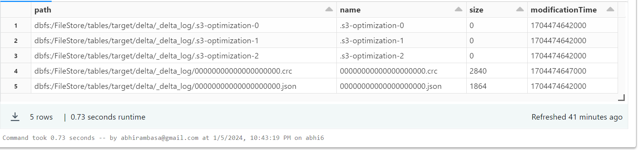

**Delta lake tables:** These tables support ACID transactions

Atomicity, consistency, isolation, durability.

**Azure data factory :** It is the cloud-based ETL and data integration service that allows you to create data-driven workflows

**Hands on:**

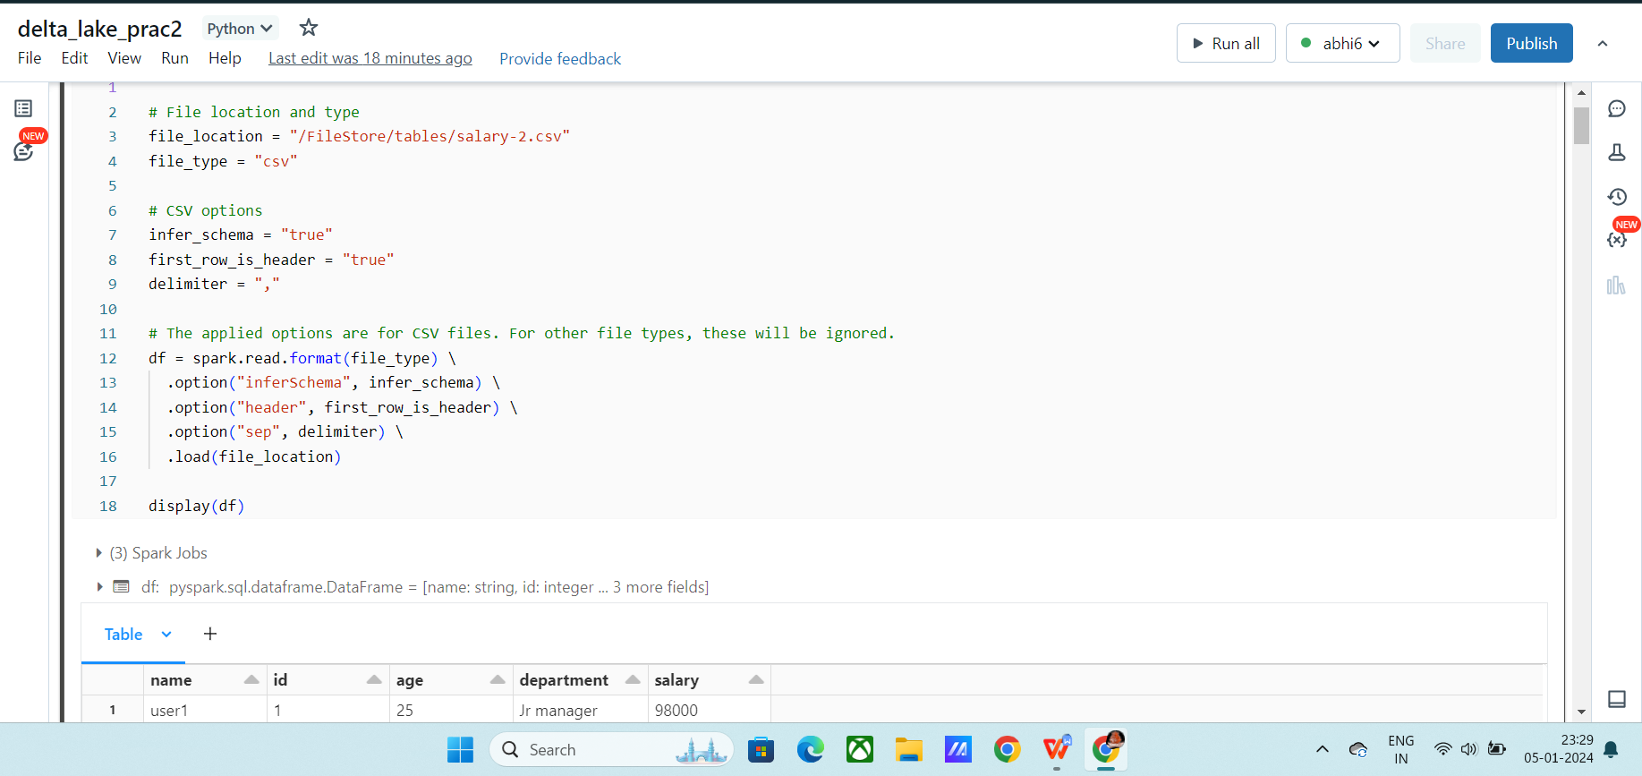

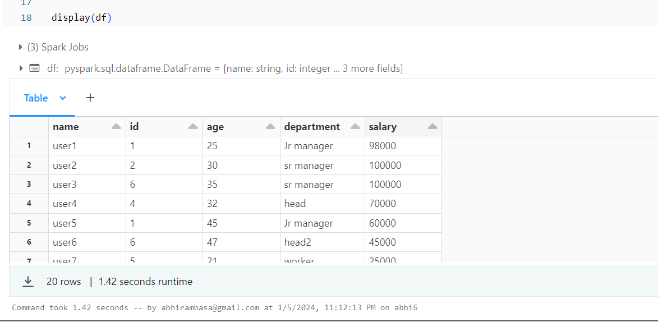

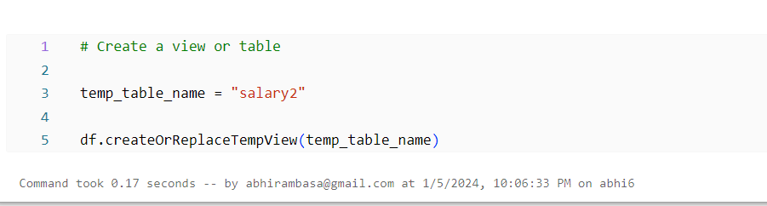

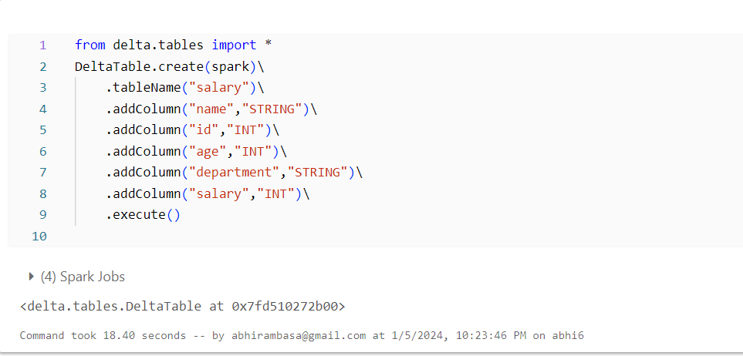

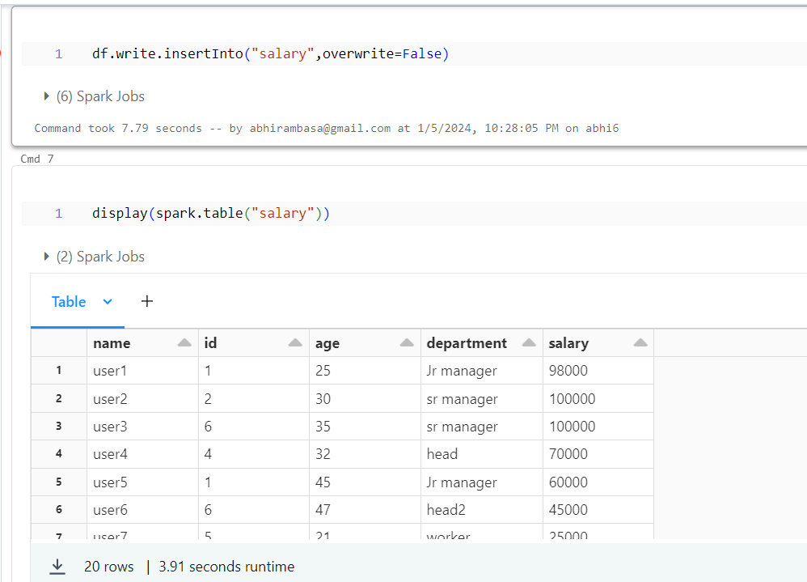

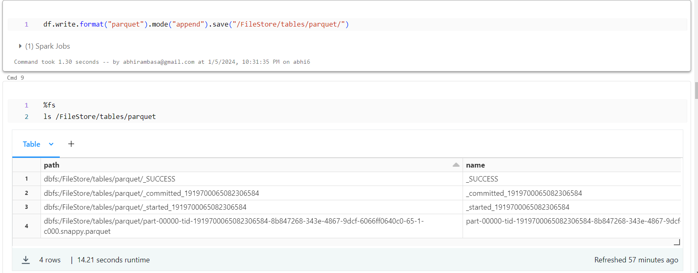

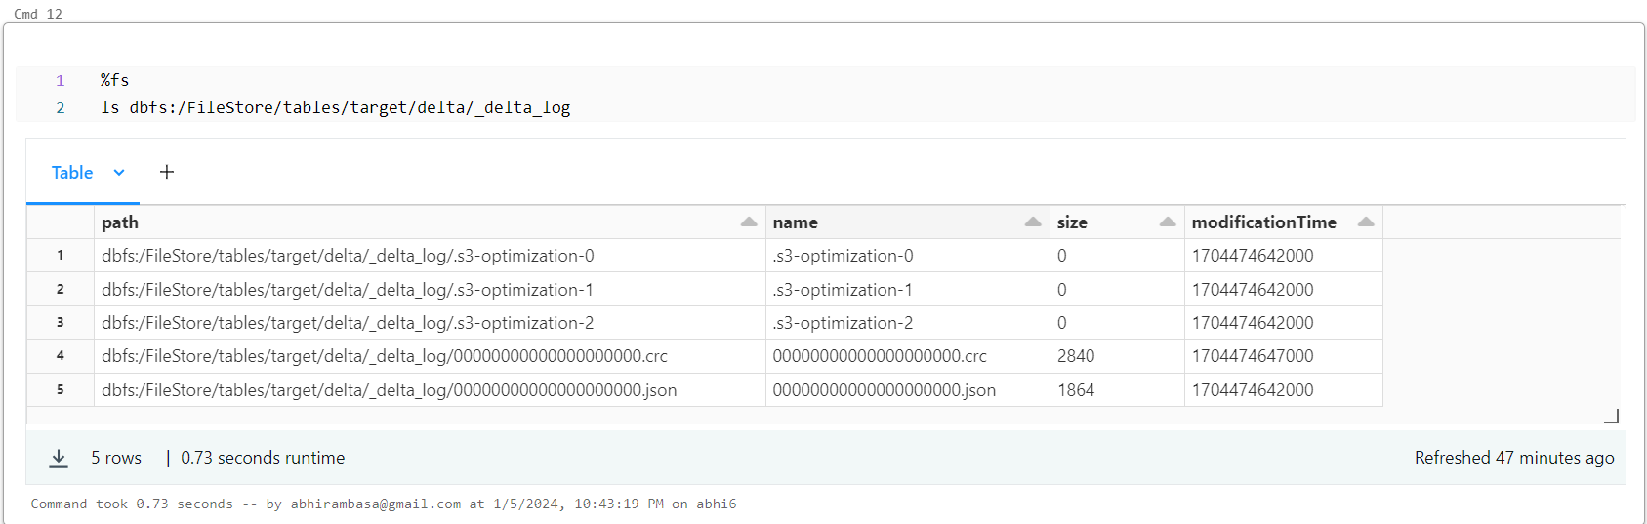

**Acid transactions:**

